**Task 04**

**Name: Abdullah Butt Roll Number: 018**

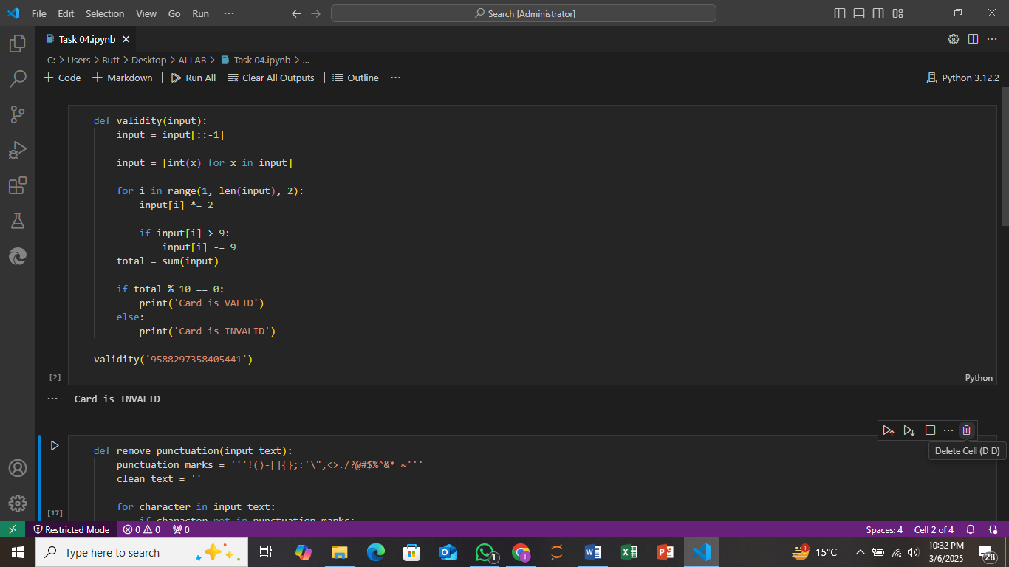

**Explanation:**

The function validity () checks if a given credit card number is valid using the **Luhn algorithm**. First, it reverses the input number to start checking from the last digit. Then, it doubles every second digit starting from the second-to-last one. If doubling a digit results in a number greater than 9, it subtracts 9 from it. After processing the digits, it sums them all together. If the total sum is divisible by 10, the card is considered valid; otherwise, it's invalid. The function prints "Card is VALID" if the card passes the check and "Card is INVALID" if it doesn’t.

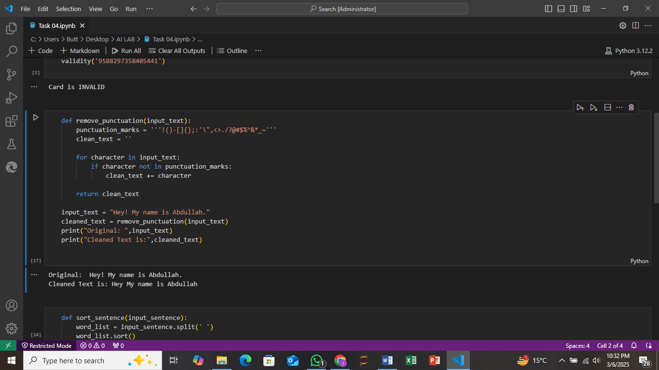

The function remove_punctuation() takes a string as input and removes any punctuation marks from it. It defines a list of punctuation characters and then checks each character in the input text. If a character is not a punctuation mark, it adds it to a new string called clean_text. Finally, it returns the cleaned text, which contains only the alphabetic characters and spaces, with all punctuation removed. The function is then tested with the string "Hey! My name is Abdullah." and the cleaned version is printed without punctuation.

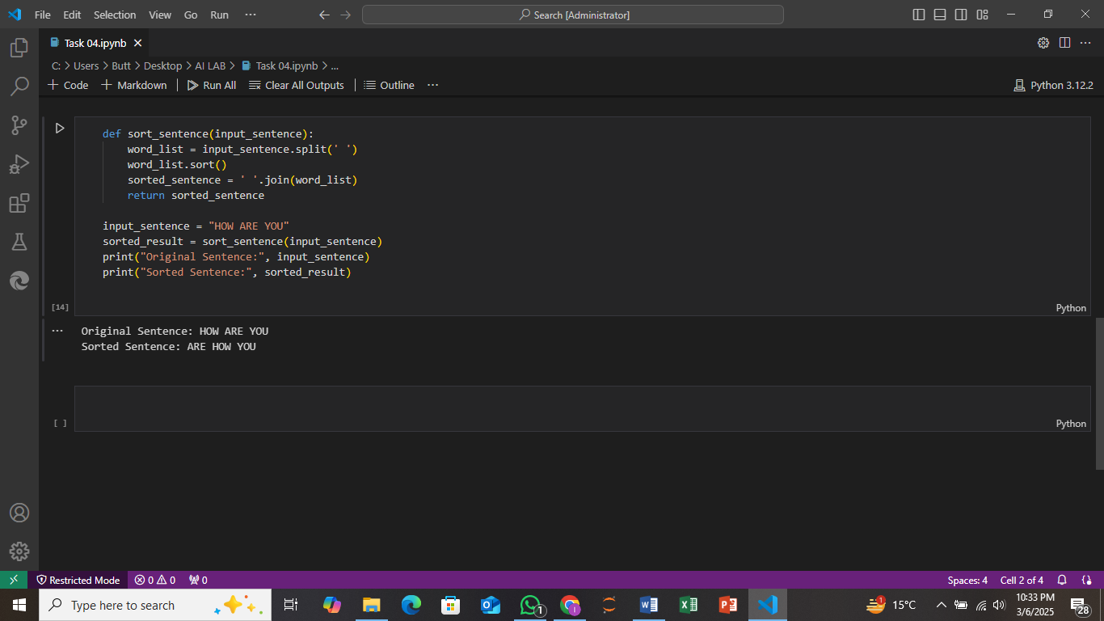

The function sort_sentence() takes a sentence as input, splits it into words, sorts the words alphabetically, and then joins them back together into a new sentence. Here's how it works: First, the sentence is split into a list of words using the split(' ') method. Next, the list of words is sorted alphabetically using the sort() method. Finally, the sorted words are combined back into a single sentence using ' '.join(word_list) and returned. For example, if the input sentence is "HOW ARE YOU", the function will sort the words alphabetically to produce "ARE HOW YOU". The function is tested with the sentence "HOW ARE YOU", and both the original and sorted sentences are printed.